Aim:Implement basic commands in R,R Graphics,Indexeing data,loading data,Additional graphical and numerical summaries .

BASIC COMMANDS IN R:

Description: R uses functions to perform operations. To run a function called funcname , we type funcname(input1, input2) , where the inputs (or arguments) input1 and input2 tell R how to run the function. A function can have any number of inputs. For example, to create a vector of numbers, we use the function c() (for concatenate). Any numbers inside the parentheses are joined together.

Program:

x <- c(1,3,2,5)

x

x = c(1,6,2)

x

y = c(1,4,3)

length(x)

length(y)

x+y

ls()

rm(x,y)

ls()

character(0)

rm(list=ls())

?matrix

x=matrix(data=c(1,2,3,4), nrow=2, ncol=2)

x’

Output:

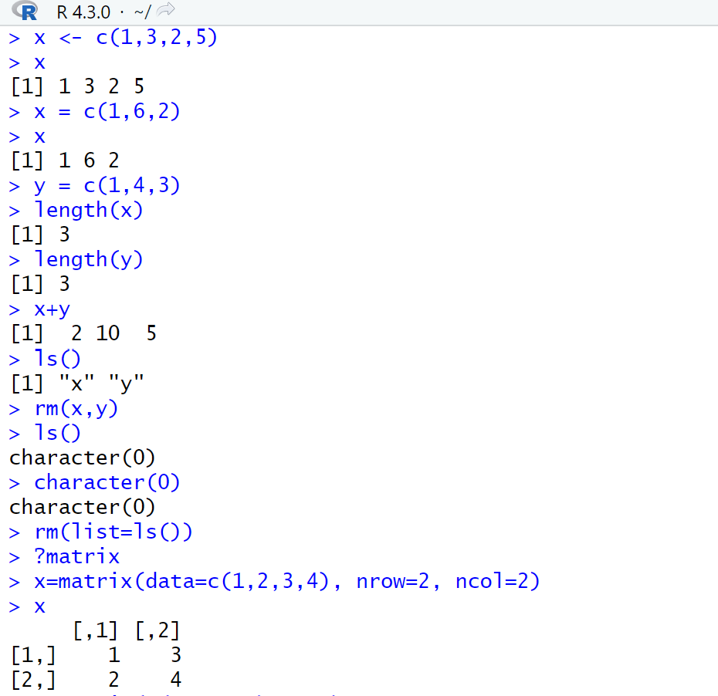

Program:

x=matrix(c(1,2,3,4) ,2,2)

matrix(c(1,2,3,4) ,2,2,byrow=TRUE)

sqrt(x)

x^2

x=rnorm(50)

y=x+rnorm(50,mean=50,sd=.1)

cor(x,y)

set.seed(1303)

rnorm(50)

set.seed(3)

y=rnorm(100)

mean(y)

var(y)

sqrt(var(y))

sd(y)

Output:

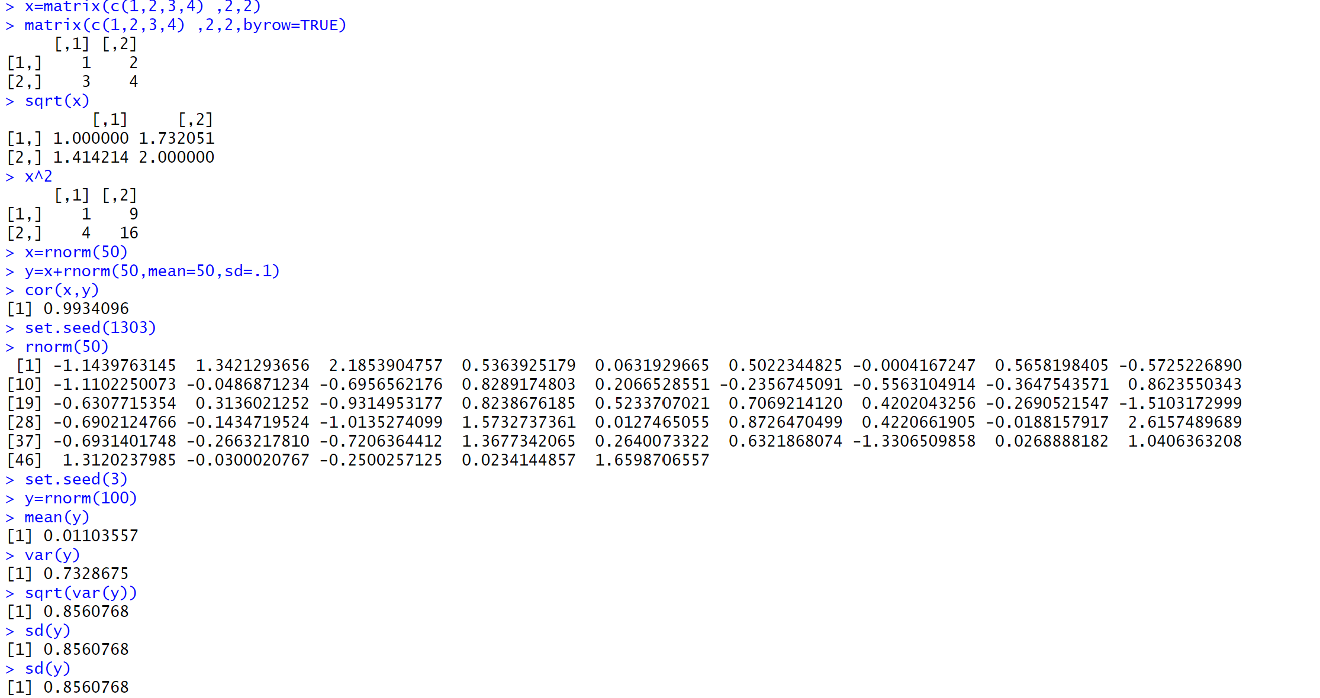

Graphics in R:

Description: The plot() function is the primary way to plot data in R . For instance, plot(x,y) produces a scatterplot of the numbers in x versus the numbers in y . There are many additional options that can be passed in to the plot() function.

Program:

x=rnorm(100)

y=rnorm(100)

plot(x,y)

plot(x,y,xlab="this is the x-axis",ylab="this is the y-axis", main="Plot of X vs Y")

pdf("Figure.pdf")

plot(x,y,col="green")

dev.off()

x=seq(1,10)

x

x=1:10

x

Output:

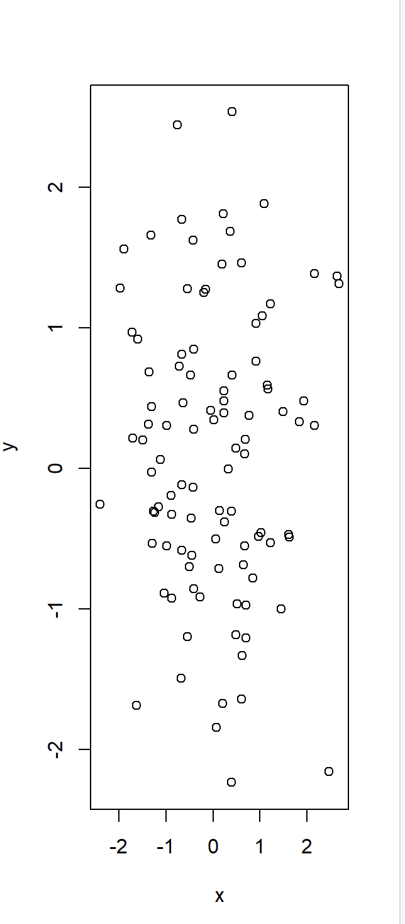 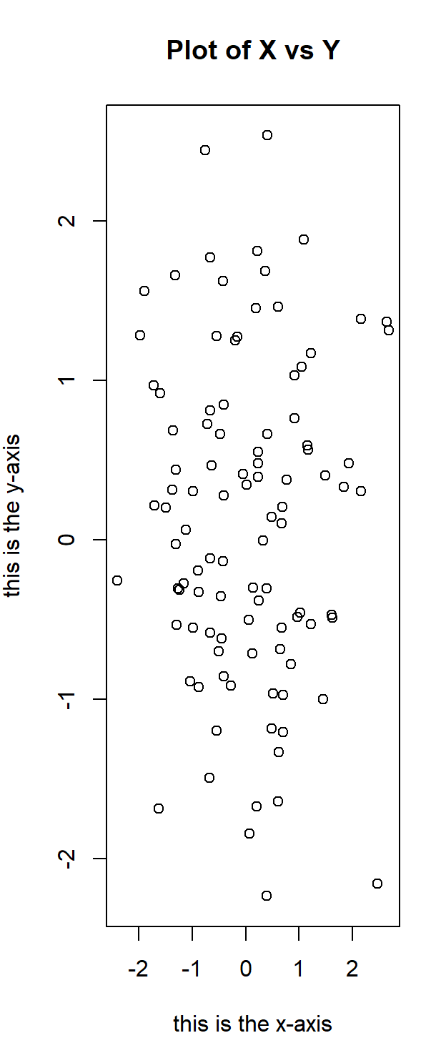

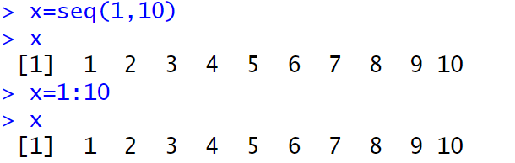

Program:

x=seq(-pi,pi,length =50)

y=x

f=outer(x,y,function(x,y)cos(y)/(1+x^2))

contour(x,y,f)

contour(x,y,f,nlevels=45,add=T)

fa=(f-t(f))/2

contour(x,y,fa,nlevels=15)

Output:

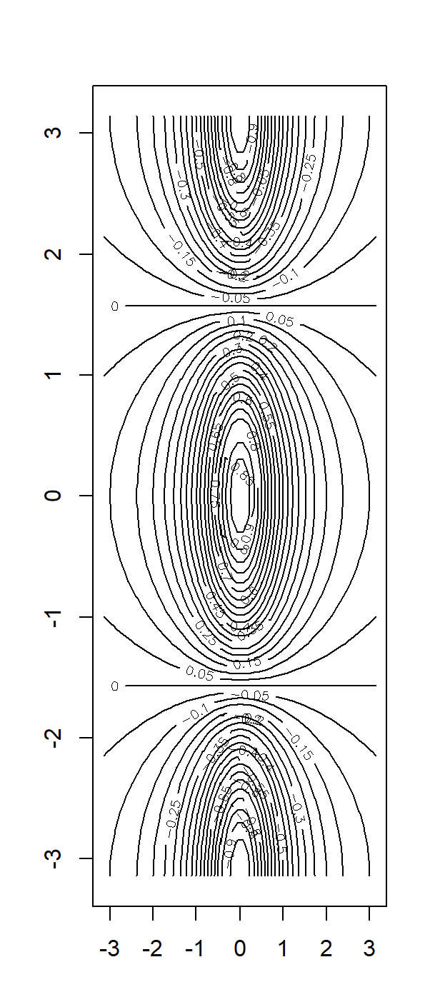 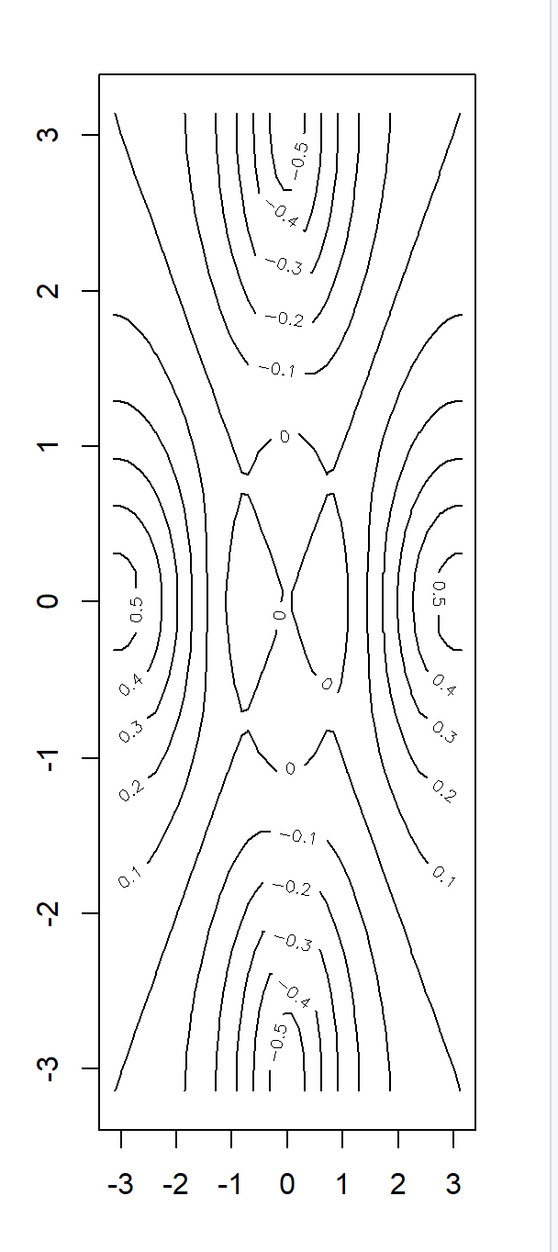

Program:

image(x,y,fa)

persp(x,y,fa)

persp(x,y,fa,theta =30)

persp(x,y,fa,theta=30,phi=20)

Output:

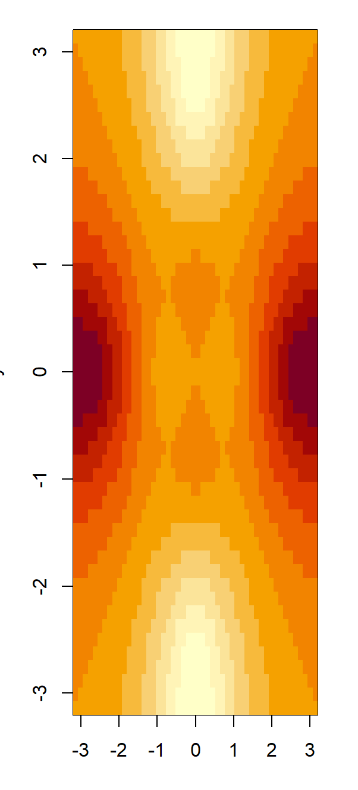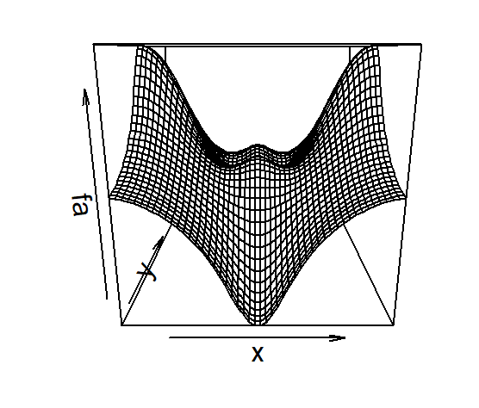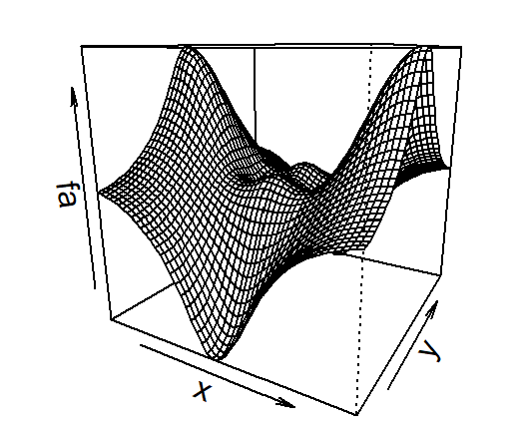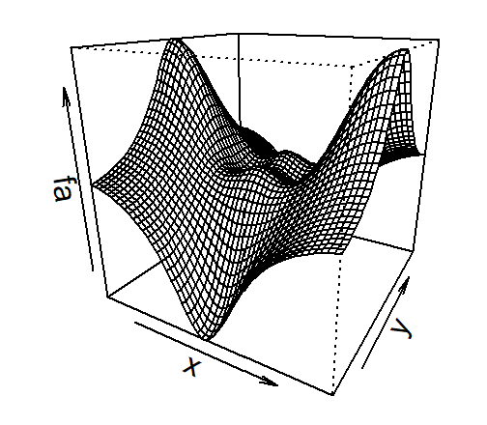

Program:

persp(x,y,fa,theta=30,phi=70)

persp(x,y,fa,theta=30,phi=40)

Output:

